SAS 9.4 Installation guide Windows 10 (32 and 64 bit)

If you have SAS 9.3 already on your system, please follow the following steps before downloading and installing 9.4. If you do not have SAS 9.3 installed on your system start from page 2 of the document.

Uninstalling SAS 9.3

1. Open "Control Panel\All Control Panel Items\Administrative Tools\Services" and stop the "SAS Document Conversion Server service." Change the "Startup type" to Disabled. (right click on the SAS document conversion server and click properties). If it is already disabled let the it stay that way, do not start the service.
2. Open "Control Panel\All Control Panel Items\Programs and Features" and uninstall the SAS Document Conversion Server.
3. Uninstall the SAS Sentiment Analysis Studio. (if installed)
4. Uninstall JMP 10. (if installed)
5. Uninstall SAS 9.3
6. Uninstall both the 32/64-bit versions of Java 6 Update 45 (or earlier).
7. Reboot the computer.
8. Manually delete the following directories: C:\Users\userid\AppData\Local\SAS C:\Users\userid\AppData\Roaming\SAS C:\ProgramData\SAS
C:\Program Files\SASHome
C:\Program Files (x86)\SAS(skip this step if the directory does not exist)
9. Open regedit.exe and delete the following from the Registry locations: HKEY_LOCAL_MACHINE\SOFTWARE\SAS Institute Inc. HKEY_LOCAL_MACHINE\SOFTWARE\Wow6432Node\SAS Institute Inc.
10. Reboot the computer. References:
Installation Note 44362: Removing SAS® 9.3 in Windows operating environments (for Basic installations only)
http://support.sas.com/kb/44/362.html

OKLAHOMA STATE UNIVERSITY 1
SAS 9.4 Installation guide Windows 10 (32 and 64 bit)

SAS 9.4 software distributed by Oklahoma State University can be downloaded from the following link. https://stwcas.okstate.edu/cas/login?service=https%3A%2F%2Fapps.okstate.edu%2Fsdc%2F

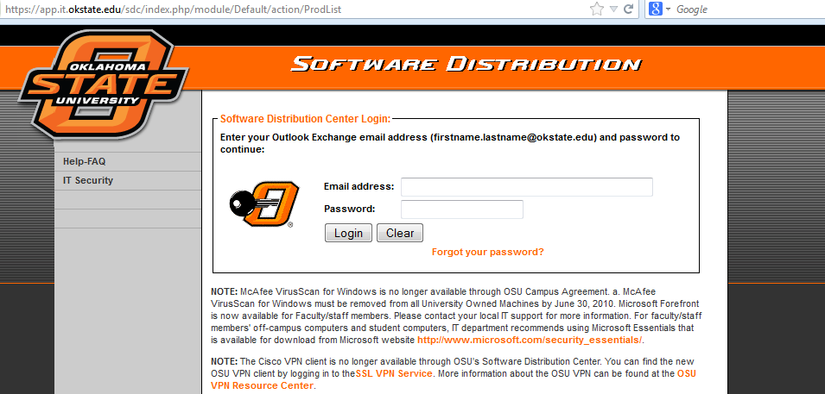

Log into and select the role as Stillwater Student.

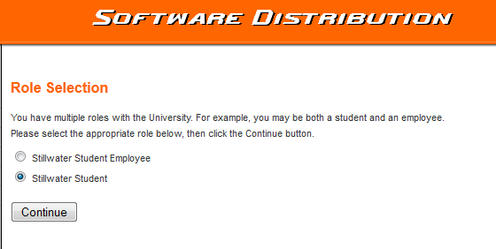



OKLAHOMA STATE UNIVERSITY 2
SAS 9.4 Installation guide Windows 10 (32 and 64 bit)

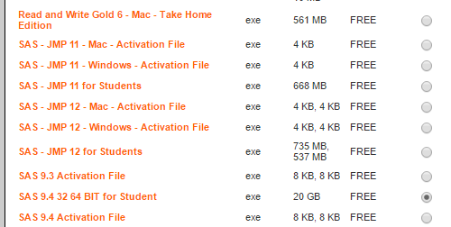

Select SAS 9.4 32 64 BIT for Student option and follow the instructions provided on the website.
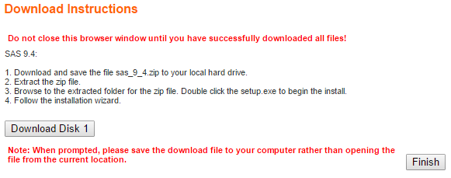

Note: This tool requires total 20GB in your C Drive.

OKLAHOMA STATE UNIVERSITY 3
SAS 9.4 Installation guide Windows 10 (32 and 64 bit)

A. Creating SAS Software Depot

1. Download the SAS 9.4 software from the software distribution center. After downloading all the disks extract each of them into a different folder.

2.Download the SAS 9.4 activation file from the software distribution center and copy the file into the sid_Files folder in the folder corresponding to Disk1.

3. Go to the extracted folder of Disk1.

4. Right click on setup.exe and run as administrator.

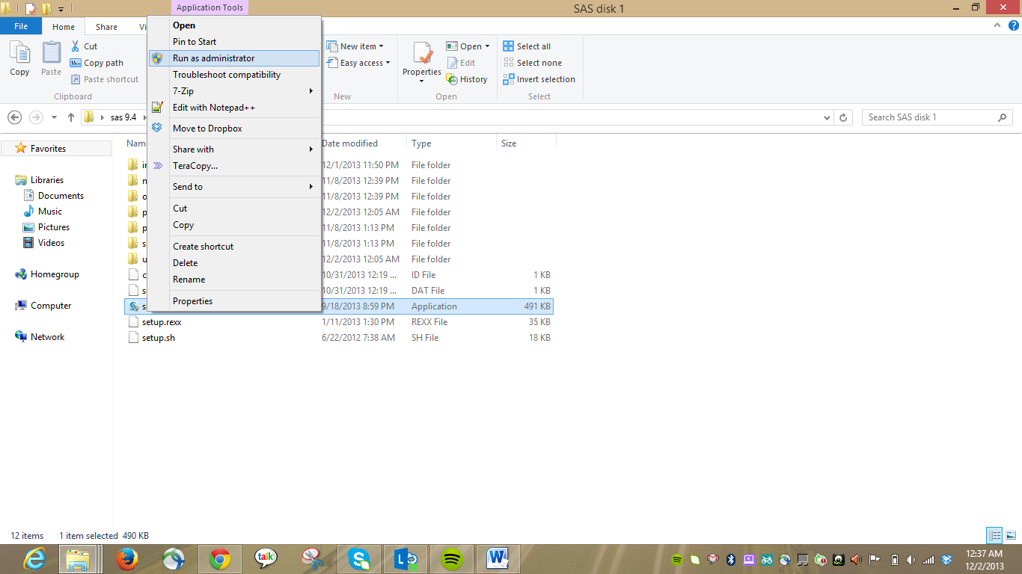

OKLAHOMA STATE UNIVERSITY 4
SAS 9.4 Installation guide Windows 10 (32 and 64 bit)

5. You will see the following SAS Deployment wizard.

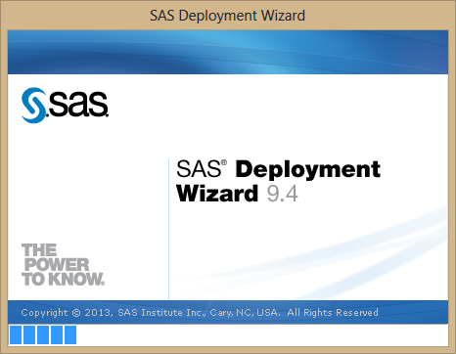

6. Select language as English and click on OK

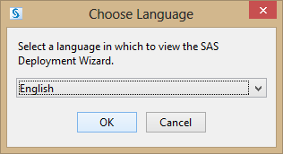

You will see the following screen next.

OKLAHOMA STATE UNIVERSITY 5
SAS 9.4 Installation guide Windows 10 (32 and 64 bit)

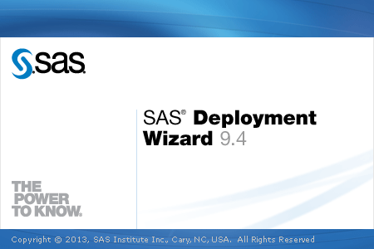

7. Select Create or Add to Software Depot option below and Click Next.

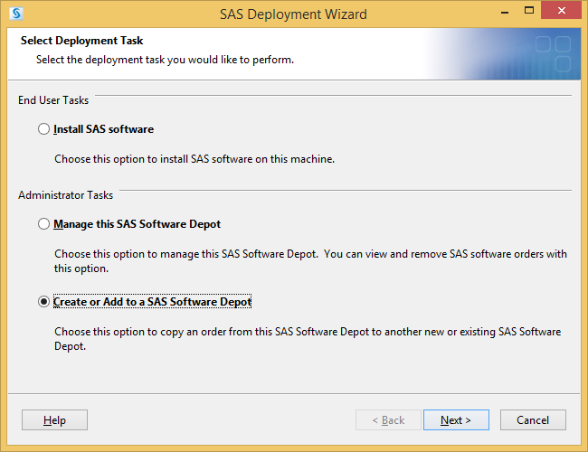

OKLAHOMA STATE UNIVERSITY 6
SAS 9.4 Installation guide Windows 10 (32 and 64 bit)

8. Click Next on the ‘Specify Order Details’ screen.

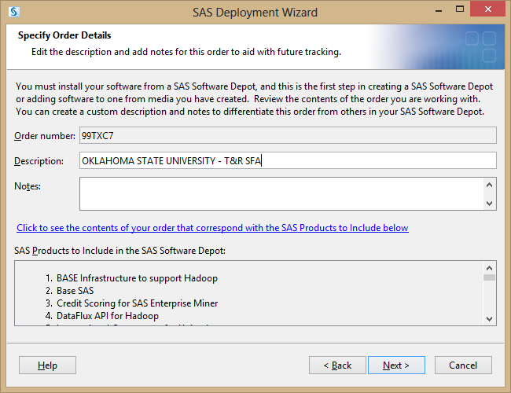

OKLAHOMA STATE UNIVERSITY 7
SAS 9.4 Installation guide Windows 10 (32 and 64 bit)

9. Select subset order contents and click next.

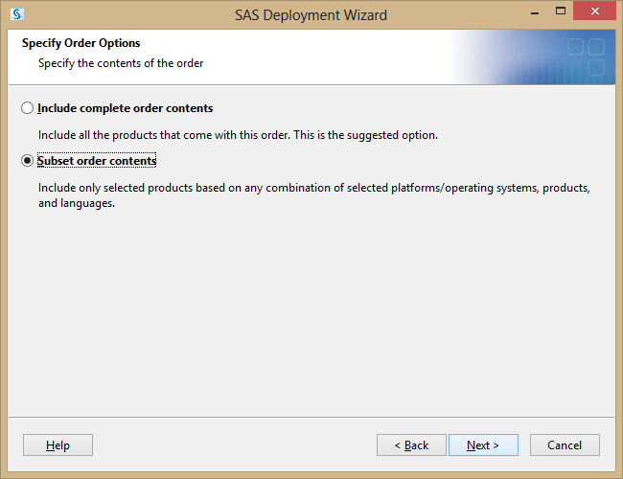

OKLAHOMA STATE UNIVERSITY 8
SAS 9.4 Installation guide Windows 10 (32 and 64 bit)

10.

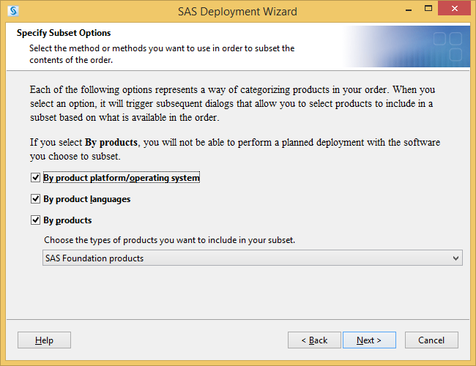

OKLAHOMA STATE UNIVERSITY 9
SAS 9.4 Installation guide Windows 10 (32 and 64 bit)

11. Select the 32-bit or 64-bit. For example, the screen below shows the options for 64-bit installation on Windows 10. Hence select Microsoft Windows and Microsoft Windows for x64. And click next.

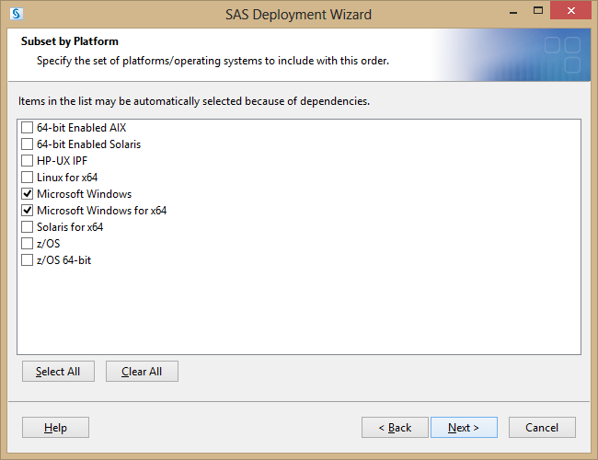

OKLAHOMA STATE UNIVERSITY 11
SAS 9.4 Installation guide Windows 10 (32 and 64 bit)

12. You can select or unselect the products that you don’t need. It is advised you proceed with the
default selection. Click Next.

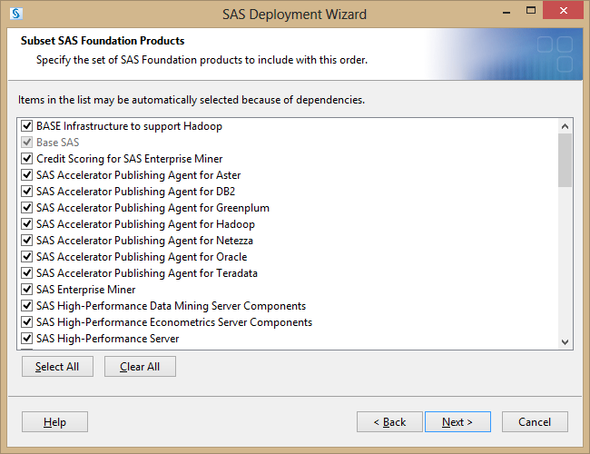

OKLAHOMA STATE UNIVERSITY 12
SAS 9.4 Installation guide Windows 10 (32 and 64 bit)

13. Select Languages. If you want only English then Clear All. Click Next.

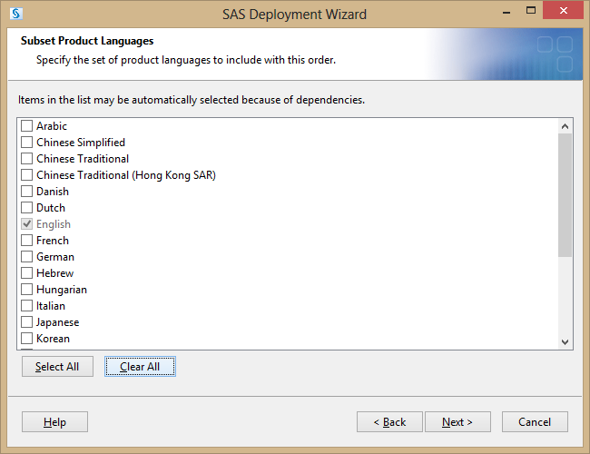

OKLAHOMA STATE UNIVERSITY 13
SAS 9.4 Installation guide Windows 10 (32 and 64 bit)

14. Specify a path where you want to create a SAS Software Depot. This could be any drive on your machine. Choose the drive that has enough space. Make a note of this path and click next

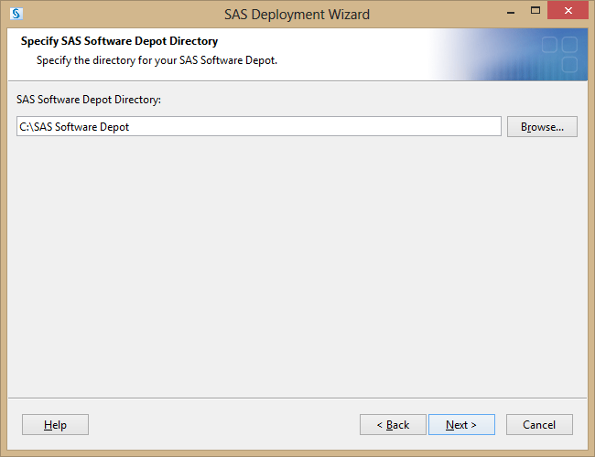

OKLAHOMA STATE UNIVERSITY 14
SAS 9.4 Installation guide Windows 10 (32 and 64 bit)

15. If you see the following, click yes.

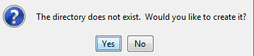

16. Click Start

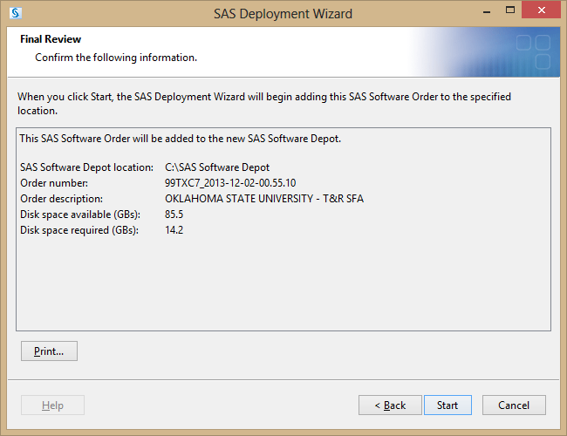

17. Click on Start

OKLAHOMA STATE UNIVERSITY 15
SAS 9.4 Installation guide Windows 10 (32 and 64 bit)

18. Contents of disk1 will get copied into the SAS depot

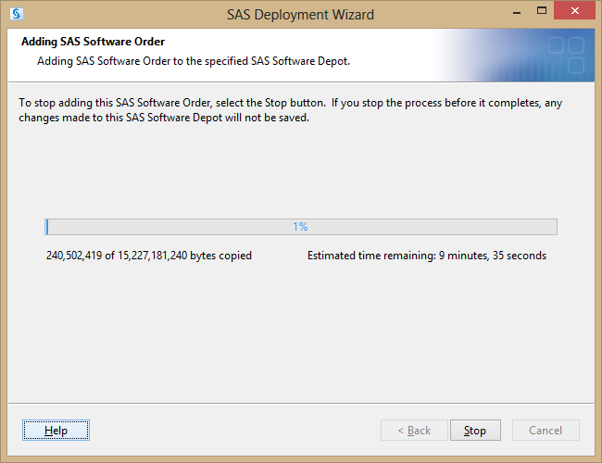

SAS 9.4 Installation guide Windows 10 (32 and 64 bit)

21. Click Finish

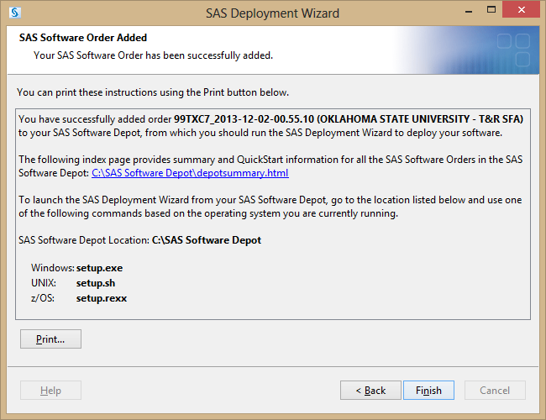

All the contents are copied into the SAS Depot.

B. Installing SAS:

If you receive a warning message like below, select the option “This program installed correctly”

OKLAHOMA STATE UNIVERSITY 19
SAS 9.4 Installation guide Windows 10 (32 and 64 bit)

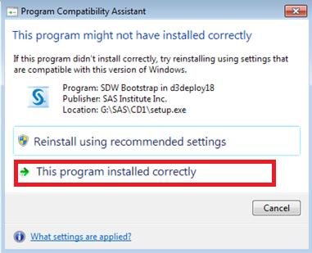

1. Go to the SAS software Depot that you have created.

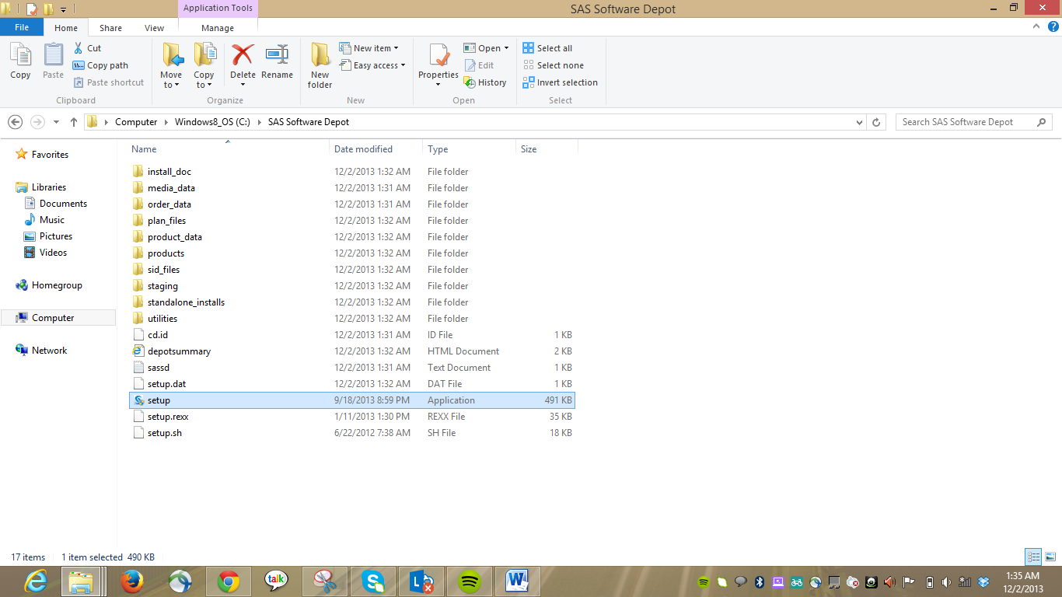

OKLAHOMA STATE UNIVERSITY 20
SAS 9.4 Installation guide Windows 10 (32 and 64 bit)

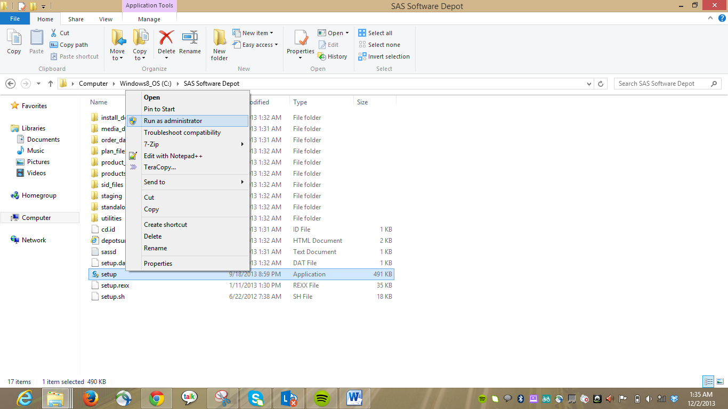

From software depot right click on Setup.exe and Run as Administrator.

2. You will see the below deployment wizard.

OKLAHOMA STATE UNIVERSITY 21
SAS 9.4 Installation guide Windows 10 (32 and 64 bit)

3. Select language as English and click on OK.

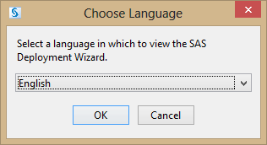

You will see the above screen after you select the language.

OKLAHOMA STATE UNIVERSITY 22
SAS 9.4 Installation guide Windows 10 (32 and 64 bit)

4. Select Install SAS software option and click Next

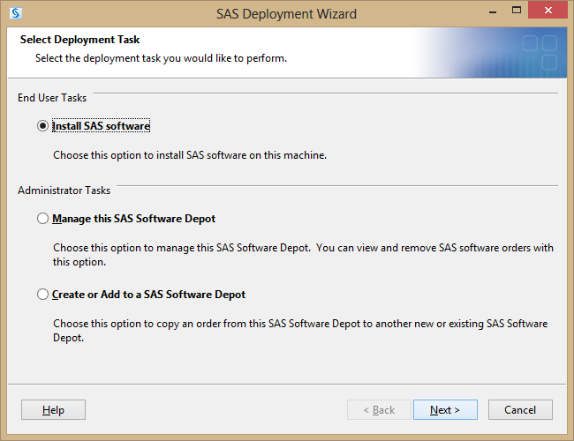

OKLAHOMA STATE UNIVERSITY 23
SAS 9.4 Installation guide Windows 10 (32 and 64 bit)

5. If you don’t have java installed, it may not get into the following screen. You have to install Java 1.6 or a later version and show the folder location as shown below. You may not get into this screen if SAS detects automatically an Existing Java Installation. Start from page 30 of this document if you do not see this screen.

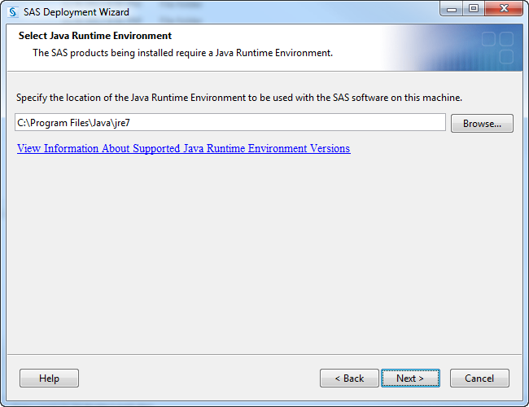

OKLAHOMA STATE UNIVERSITY 24
SAS 9.4 Installation guide Windows 10 (32 and 64 bit)

6. Note: Java Version Requirement

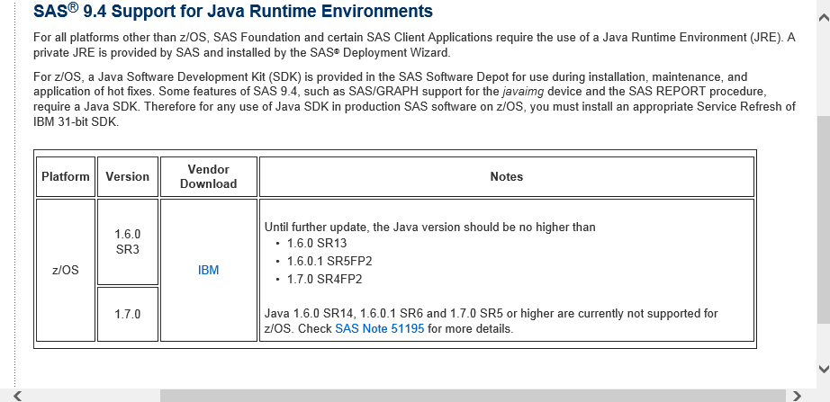

7. Click Next

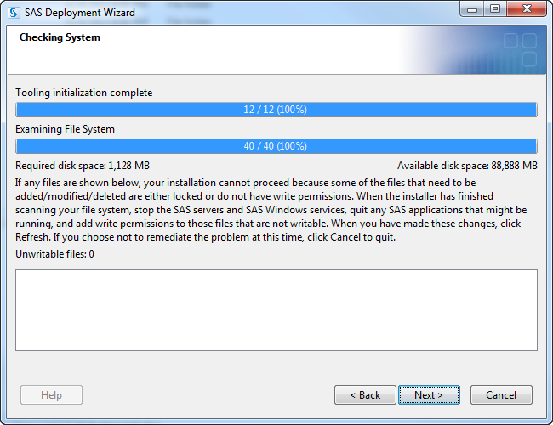

OKLAHOMA STATE UNIVERSITY 25
SAS 9.4 Installation guide Windows 10 (32 and 64 bit)

8. Click Start

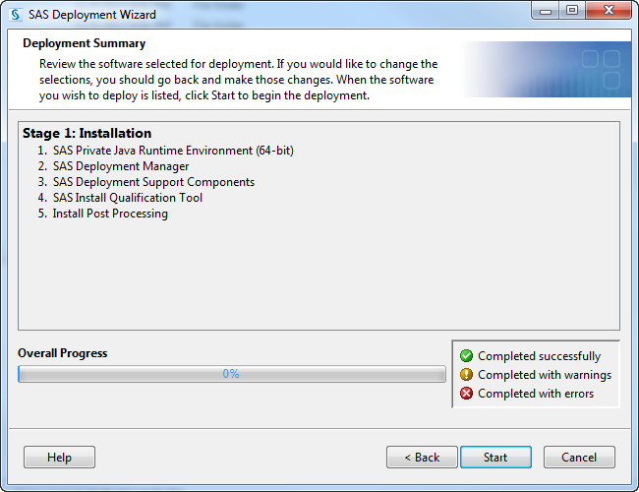

OKLAHOMA STATE UNIVERSITY 26
SAS 9.4 Installation guide Windows 10 (32 and 64 bit)

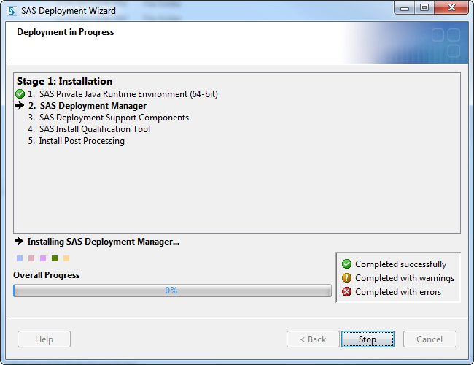

OKLAHOMA STATE UNIVERSITY 27
SAS 9.4 Installation guide Windows 10 (32 and 64 bit)

10. Click Next

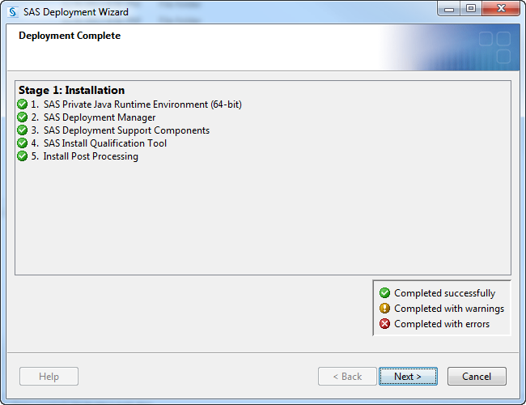

OKLAHOMA STATE UNIVERSITY 28
SAS 9.4 Installation guide Windows 10 (32 and 64 bit)

11. Click Finish

At this point you finished installing Java Run Time Environment and Deployment Manager Components.

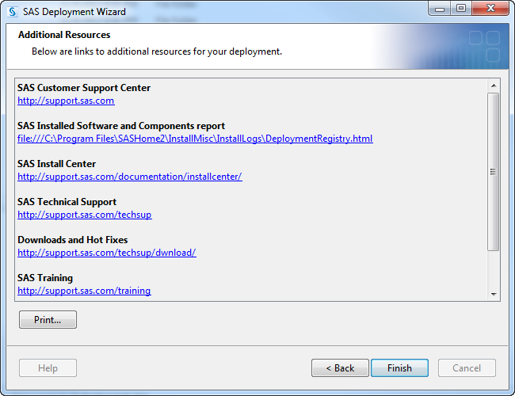

OKLAHOMA STATE UNIVERSITY 29
SAS 9.4 Installation guide Windows 10 (32 and 64 bit)

1. Now Go back to the SAS software Depot that you have created.

From software depot right click on Setup.exe and Run as Administrator.

OKLAHOMA STATE UNIVERSITY 30
SAS 9.4 Installation guide Windows 10 (32 and 64 bit)

2. You will see the below deployment wizard.

3. Select language as English and click on OK.

OKLAHOMA STATE UNIVERSITY 31
SAS 9.4 Installation guide Windows 10 (32 and 64 bit)

You will see the above screen after you select the language.

OKLAHOMA STATE UNIVERSITY 32
SAS 9.4 Installation guide Windows 10 (32 and 64 bit)

4. Select Install SAS software option and click Next

OKLAHOMA STATE UNIVERSITY 33
SAS 9.4 Installation guide Windows 10 (32 and 64 bit)

5. By default SASHome is selected as path. Click Next

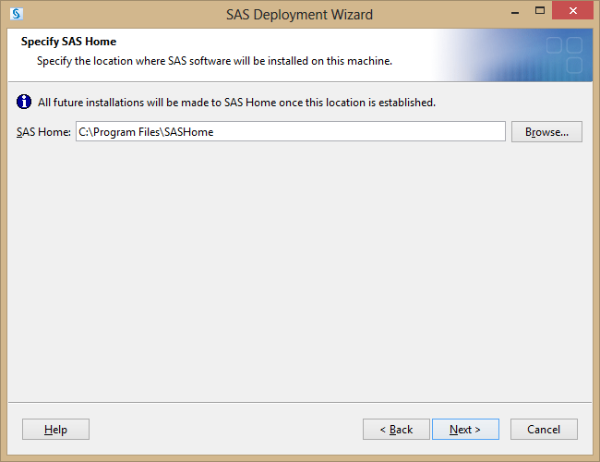

OKLAHOMA STATE UNIVERSITY 34
SAS 9.4 Installation guide Windows 10 (32 and 64 bit)

6. Below, Select products you want to install. By default some are selected, if you want additional products to be installed select them. Click next

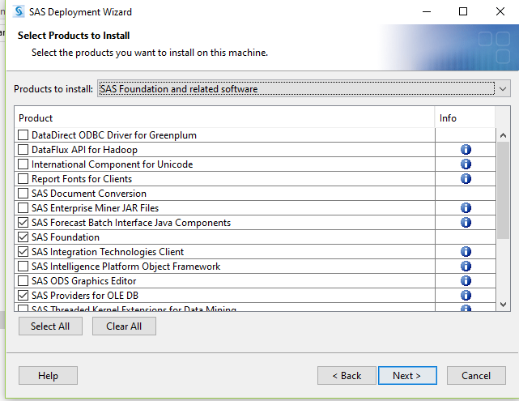

7. select 64-bit Native Mode or 32-bit Compatibility mode depending on the properties of your system and click Next

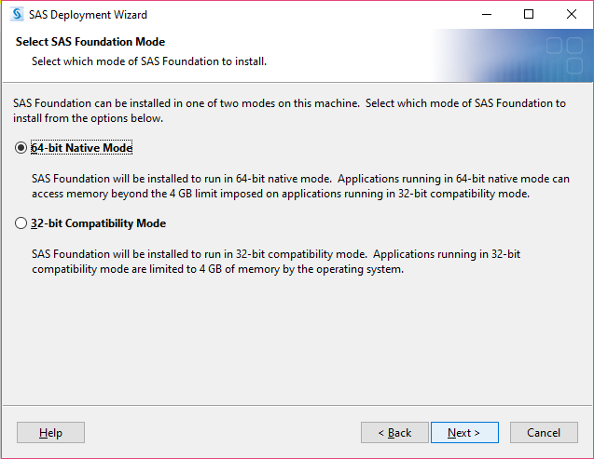

OKLAHOMA STATE UNIVERSITY 35
SAS 9.4 Installation guide Windows 10 (32 and 64 bit)

8. Click next on the screen below.

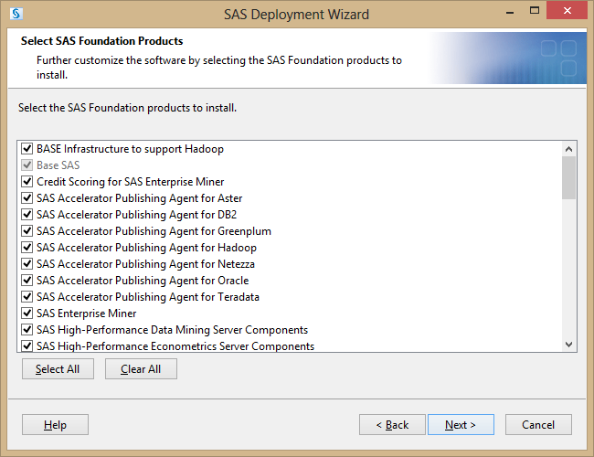

OKLAHOMA STATE UNIVERSITY 36
SAS 9.4 Installation guide Windows 10 (32 and 64 bit)

9. The path to the SAS installation Data File will default. If you see a blank field, then provide the path to the SAS installation Data file. This file will be located in the Sid_files folder within SAS Software Depot. This is a text file with name ending in _wrkstn. Click Browse to select the installation file. If this folder is empty move the SAS activation file downloaded in step 2 (creating SAS software depot) into the Sid_Files folder. After selection click Next.

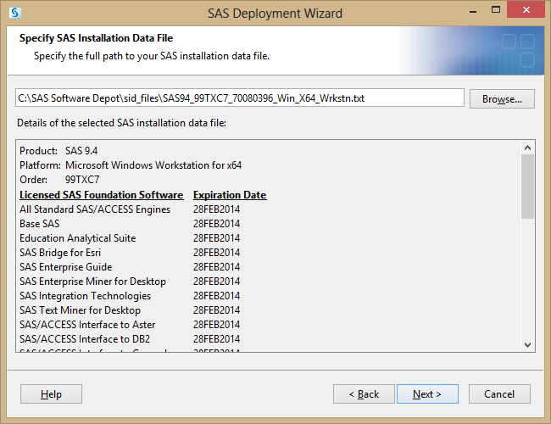

OKLAHOMA STATE UNIVERSITY 37
SAS 9.4 Installation guide Windows 10 (32 and 64 bit)

10. Click Next.

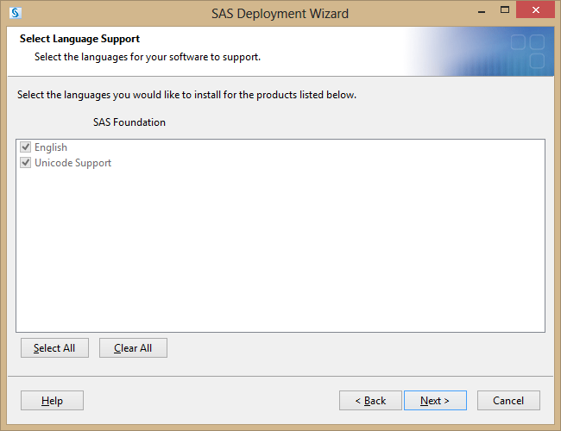

OKLAHOMA STATE UNIVERSITY 38
SAS 9.4 Installation guide Windows 10 (32 and 64 bit)

11. Click Next

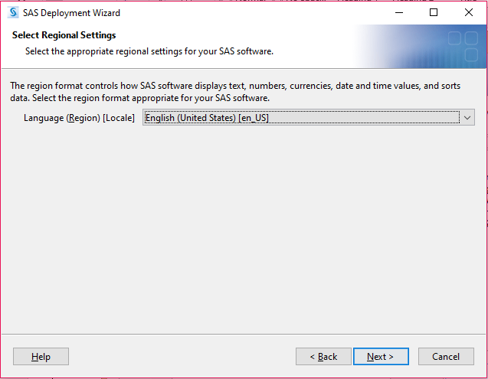

OKLAHOMA STATE UNIVERSITY 39
SAS 9.4 Installation guide Windows 10 (32 and 64 bit)

13. Click next.

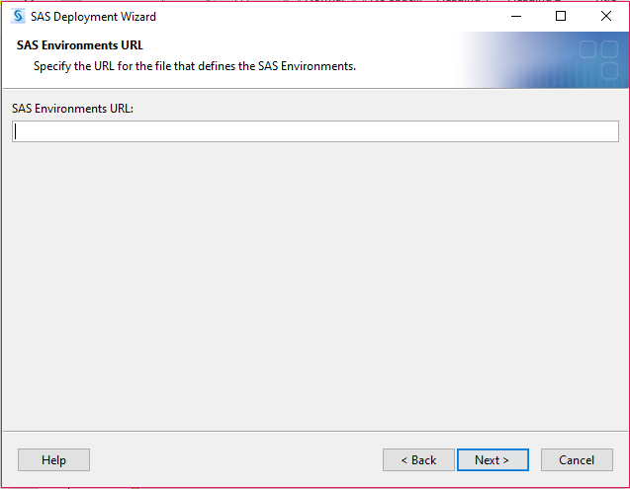

OKLAHOMA STATE UNIVERSITY 40
SAS 9.4 Installation guide Windows 10 (32 and 64 bit)

14. The fields on the screen will default from your machine.

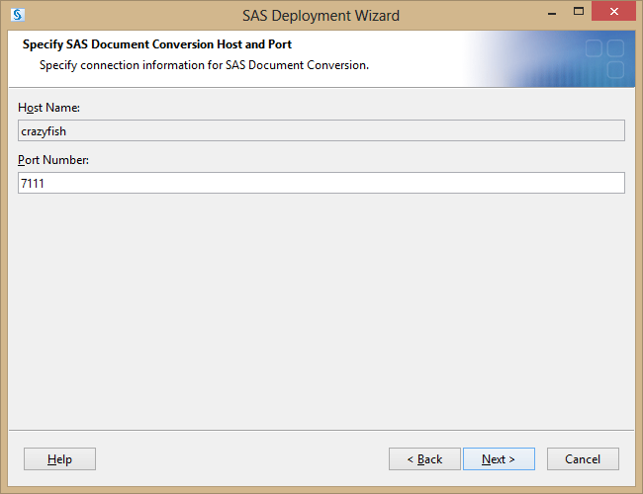

15. Deselect the Configure SAS Studio Basic option and click Next.

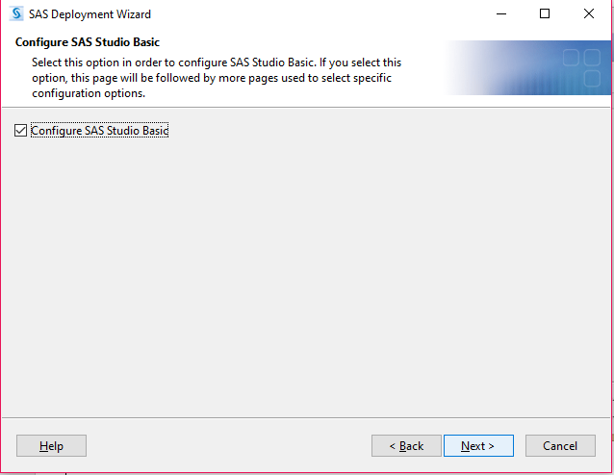

OKLAHOMA STATE UNIVERSITY 41
SAS 9.4 Installation guide Windows 10 (32 and 64 bit)

16. on screen below after 100% completion click next

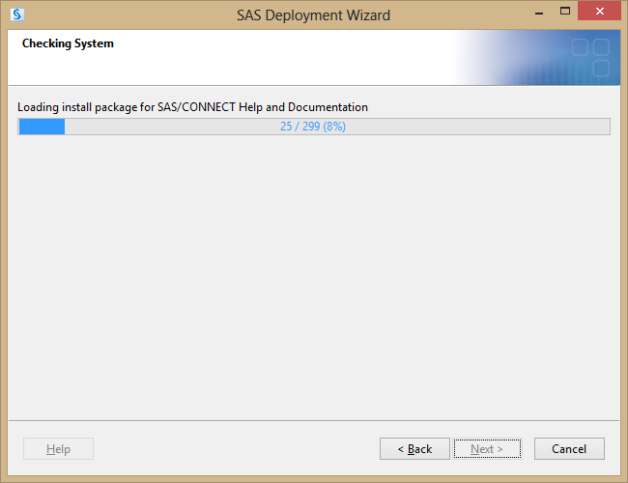

OKLAHOMA STATE UNIVERSITY 42
SAS 9.4 Installation guide Windows 10 (32 and 64 bit)

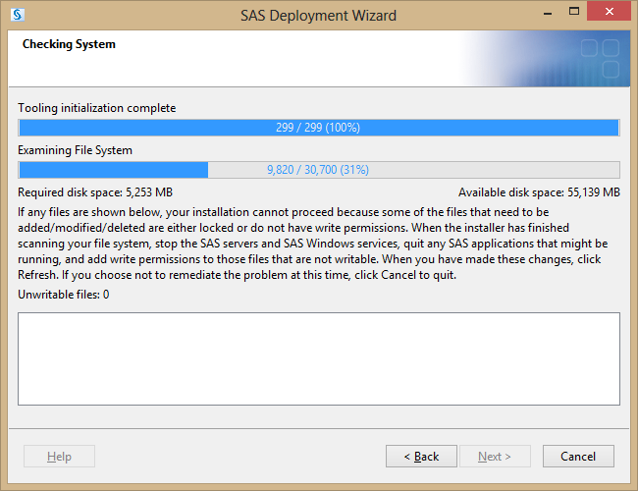

OKLAHOMA STATE UNIVERSITY 43
SAS 9.4 Installation guide Windows 10 (32 and 64 bit)

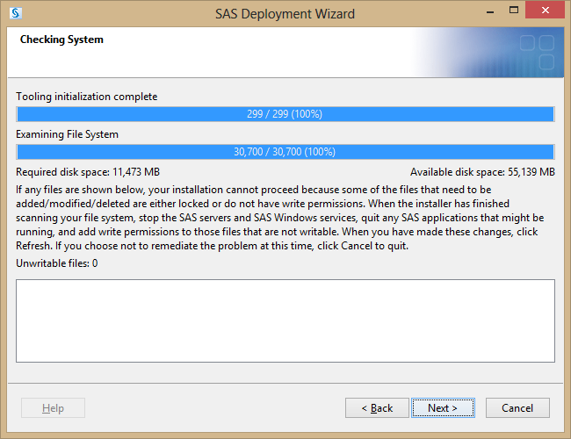

OKLAHOMA STATE UNIVERSITY 44
SAS 9.4 Installation guide Windows 10 (32 and 64 bit)

17. Click Start to initiate installation. It will take around 30 minutes.

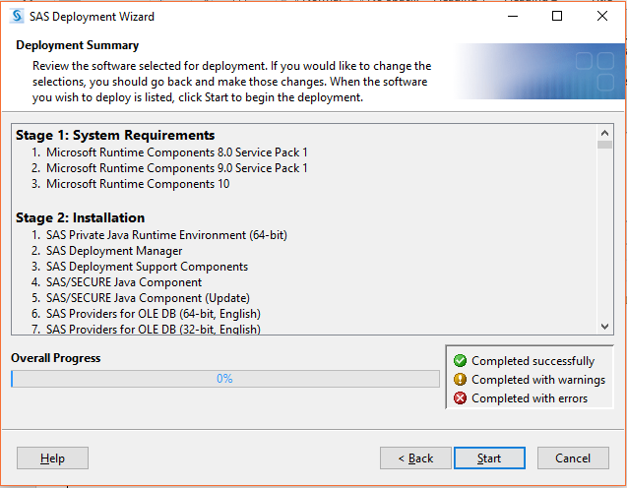

OKLAHOMA STATE UNIVERSITY 45
SAS 9.4 Installation guide Windows 10 (32 and 64 bit)

18. After Completing click next below

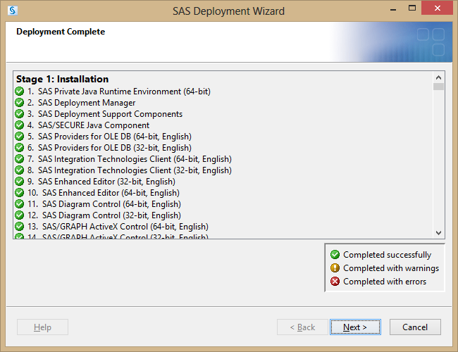

OKLAHOMA STATE UNIVERSITY 46
SAS 9.4 Installation guide Windows 10 (32 and 64 bit)

19. Click Finish on the below screen.

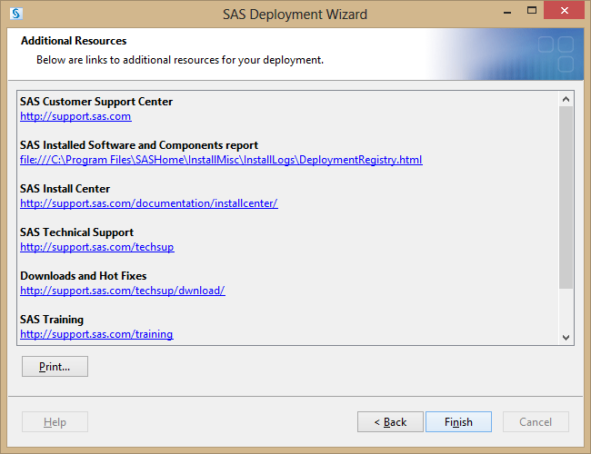

OKLAHOMA STATE UNIVERSITY 47

